# Table formats

This document describes how the tables used for this portfolio activity are organized. The organization database contains the following two tables:

* log_in_attempts
* employees

## log_in_attempts

The log_in_attempts table has the following columns:

* event_id: The identification number assigned to each login event
* username: The username of the employee
* login_date: The date the login attempt was recorded
* login_time: The time the login attempt was recorded
* country: The country where the login attempt occurred
* ip_address: The IP address of that employee’s machine
* success: The success of the login attempt; FALSE indicates a failed attempt

In the MariaDB shell, these columns are returned as:



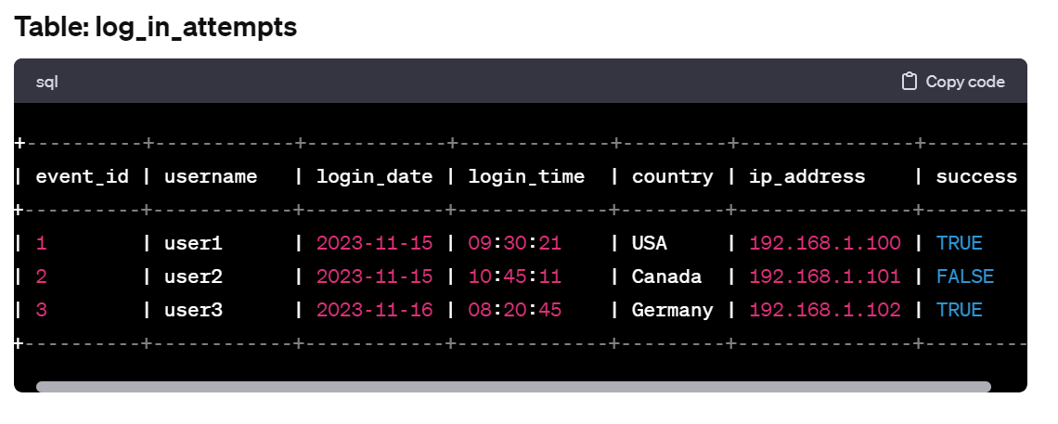

employees

The employees table has the following columns:

* employee_id: The identification number assigned to each employee
* device_id: The identification number assigned to each device used by the employee
* username: The username of the employee
* department: The department the employee is in
* office: The office the employee is located in

In the MariaDB shell, these columns are returned as:



